X`

- Logon to Azure with your RCSid and go to the ITWS1100 Lab
  - ITWS-Student-DTLab-RPI - Microsoft Azure
https://portal.azure.com/#@rpi.edu/resource/subscriptions/92cc93c6-57ae-4ede-ab97-56dd35308fb5/resourceGroups/student-dtlab/providers/Microsoft.DevTestLab/labs/ITWS-Student-DTLab-RPI/overview

- Click +Add

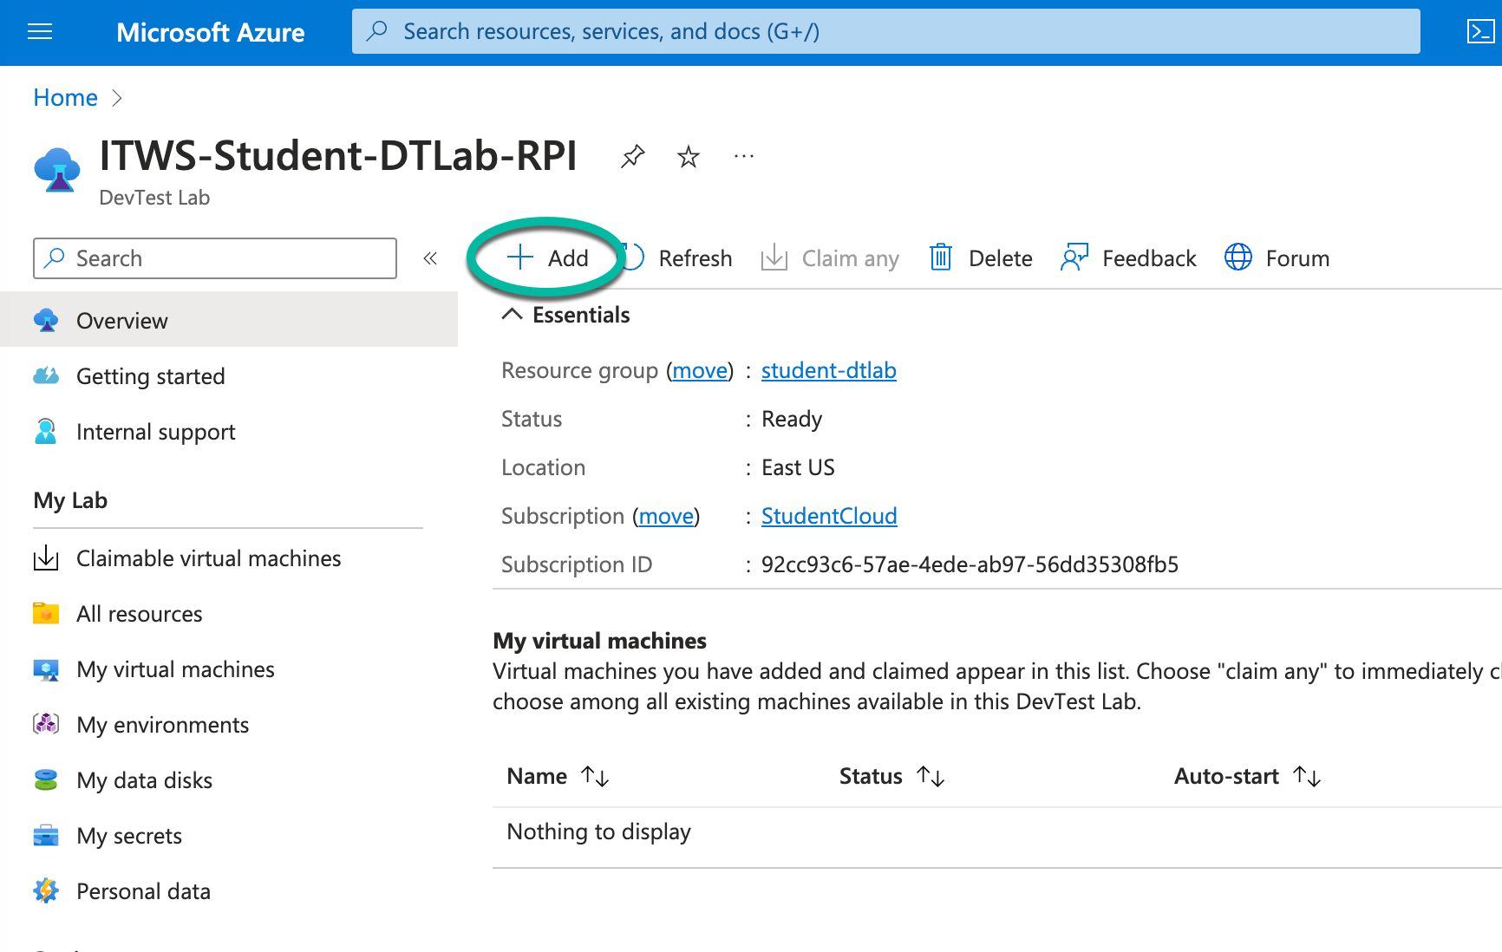

- Select ubuntu22-publicip-apache2
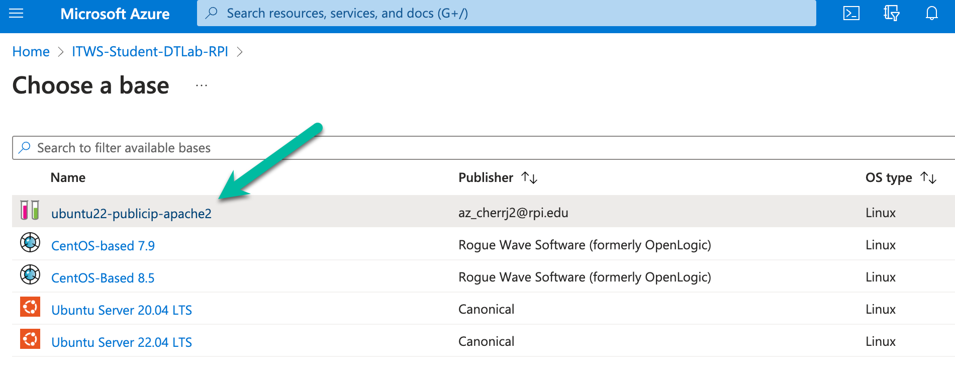

- Fill out the following fields
  - Virtual Machine Name – Your RCSid followed by RPI (eg rplotkaRPI)
  - User Name – Your RCSid
  - Password – pick a password
    - NOT your RCS password
    - REMEMBER IT!!!
  - Leave the rest as
  - Click Create

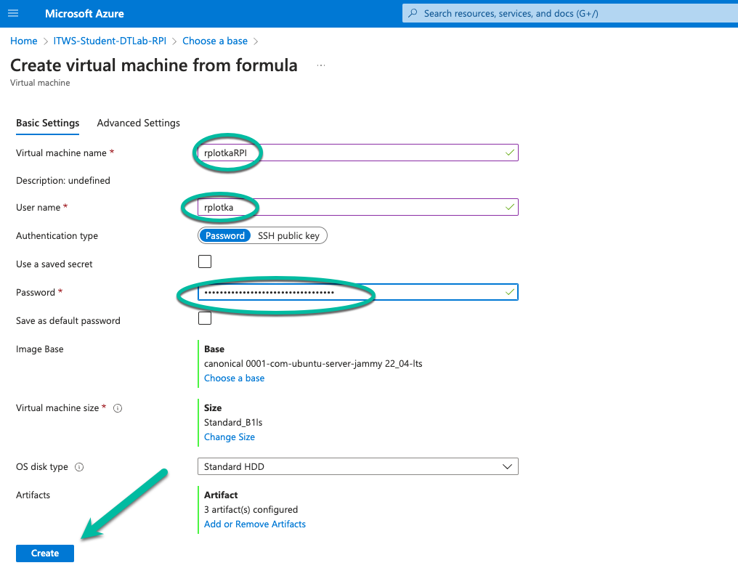

- The system will now create your Virtual Machine (VM)Click on your VM

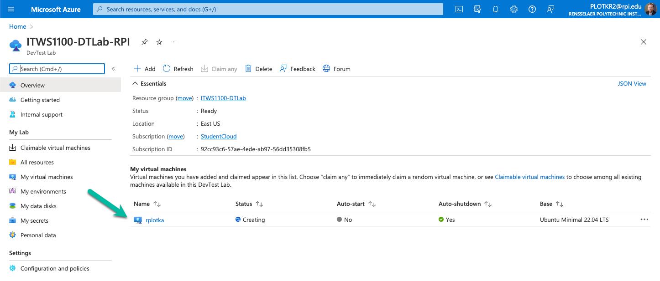

- Notice your VM’s public Fully Qualified Domain Name (FQDM)
  - Make a note of it

